Name | Atul sharma
UID no. | 2021700060
Experiment No. | 1

AIM: | Aim – To implement the various functions e.g. linear, non-linear, quadratic, exponential etc.
Program 1
PROBLEM STATEMENT : | Fn : -  ln(n) 2^lg(n) 2^n nlg(n) sqrt(lgn) lg(lg(n)) lg(n)
  n | n! | lg(n!) | lg(n) | n^3 | n | (3/2)^n
PROGRAM: | #include <stdio.h>  #include<math.h>  int number(int n){  return n;  }  double cube(double n){  return n*n*n;  }  double valueE(double n){  return log10(n);  }  float power(float x,float n){  return pow(2.0,n);  }  double lnofis(double n){  return log(n);  }  double nlogis(double n){  return n*log10(n);  }  double loglogn(double n){  return log10(log10(n));}  float squarerootlg(float n){  return sqrt(log10(n));  }  double logFactorial(int n) {  double result = 0.0;  for (int j = 1; j <= n; j++) {  result += log10(j);  }  return result;  }  unsigned long int powerlogn(float x,float n){  return pow(x,log10(n));  }  unsigned long int threeupontwo(float k,float n){  return pow(3.0/2.0,n);  }  double factorial(int n) {  double result = 1;  for (int k = 1; k <= n; k++) {  result *= k;  }  return result;  }  int main(){  for(int i=0;i<=100;i=i+10){  printf("\n");  printf( "number is %d\n " , number(i));  printf( "the ans of cube %lf\n ", cube(i));  printf( "soln of log %lf \n " , valueE(i));  printf( "soln of ln is %lf \n" , lnofis(i));  printf( "soln of n*log %lf \n " , nlogis(i)) ;  printf( "soln of log(log(n)) %lf\n " , loglogn(i));  printf( "power of 2 is %f \n " , power(2.0,i));  printf( "sqrt of logn is %f \n " , squarerootlg(i));  printf( "factorial of logn %lf \n " , logFactorial(i));  printf( "2 power of logn %lu \n " , powerlogn(2.0,i));  printf( "3/2 power of n is %lu\n " , threeupontwo(3.0/2.0,i));  printf( "Factorial of is %lf\n", factorial(i));  }  return 0;  }
RESULT:
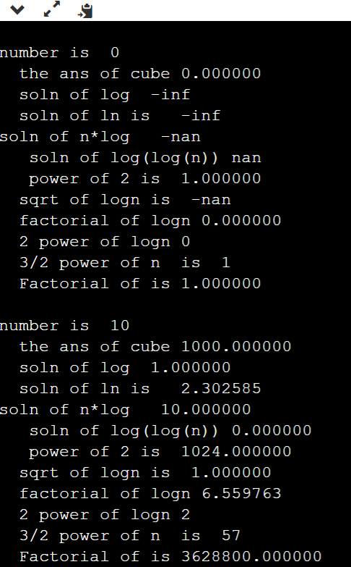

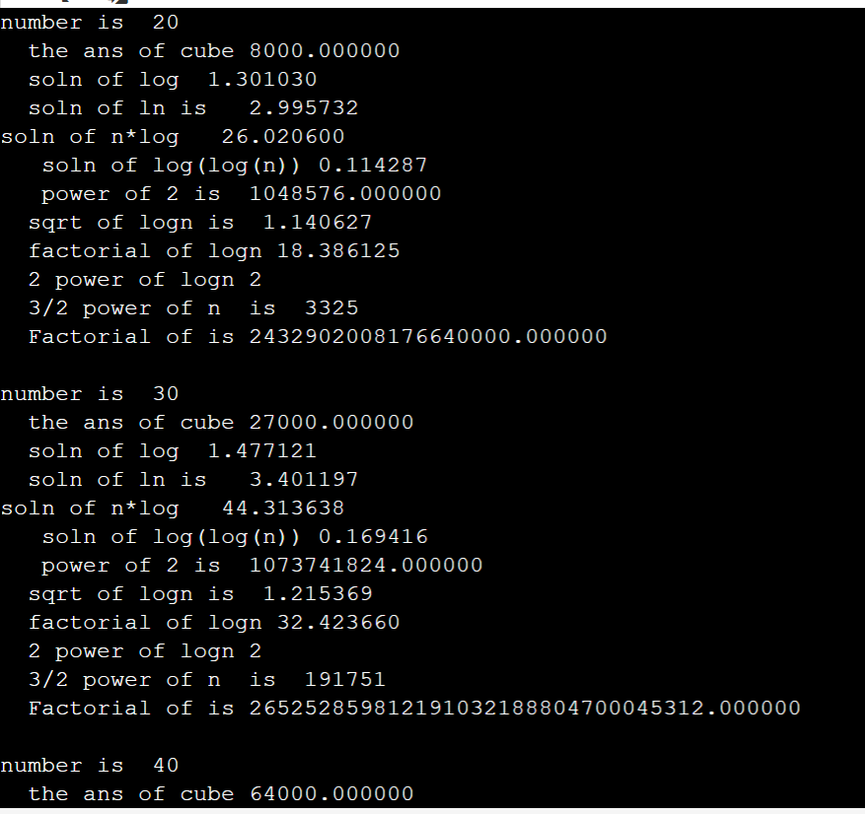

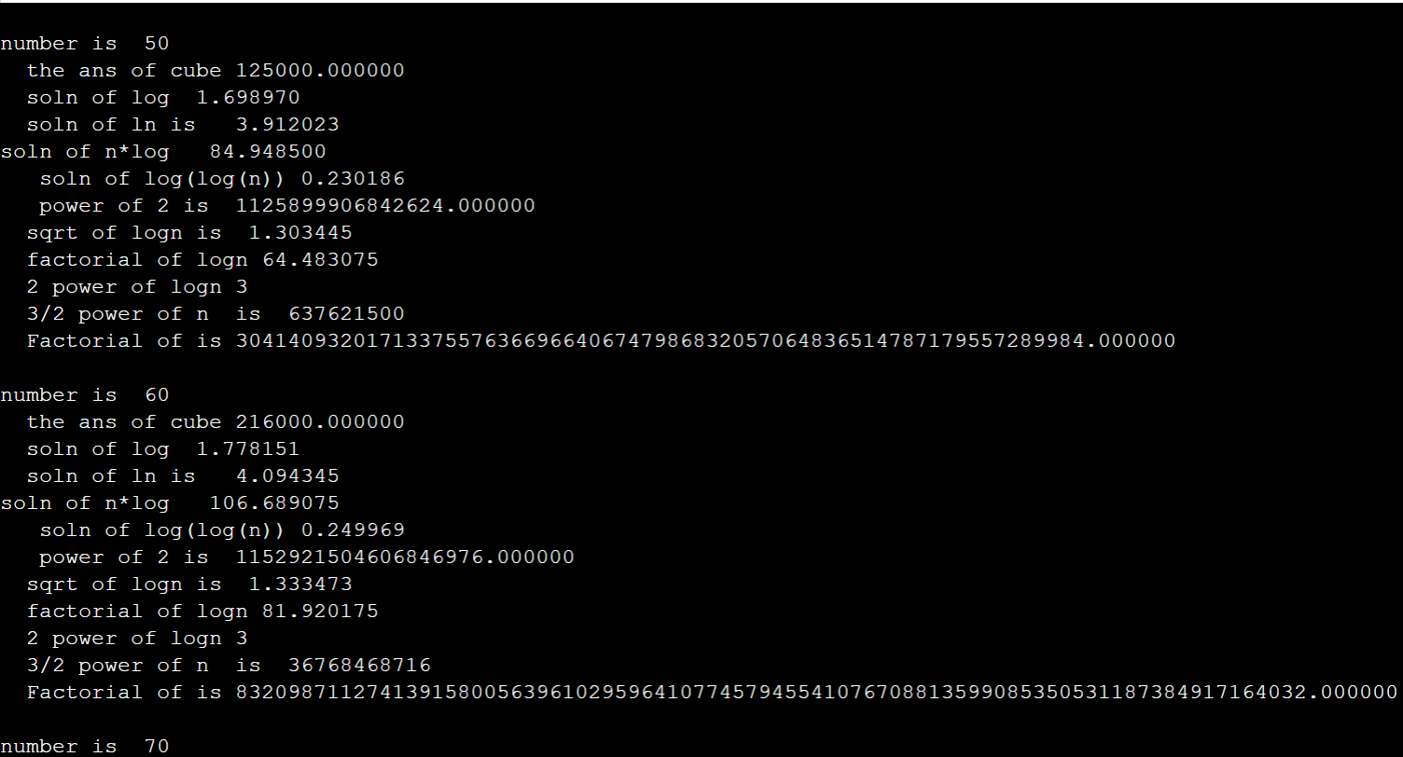

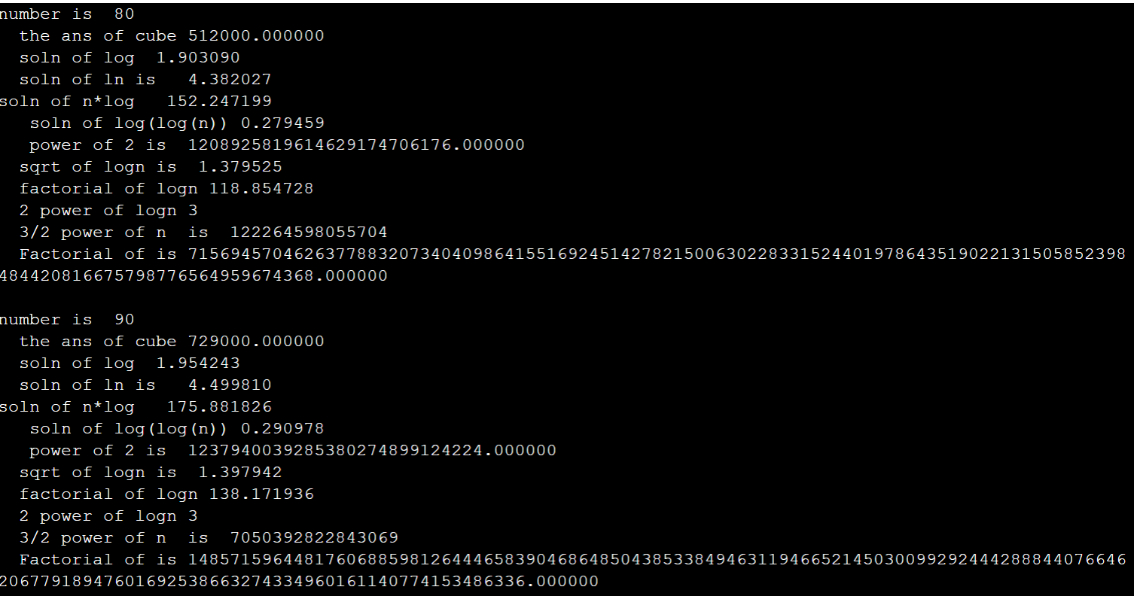

GRAPH : | 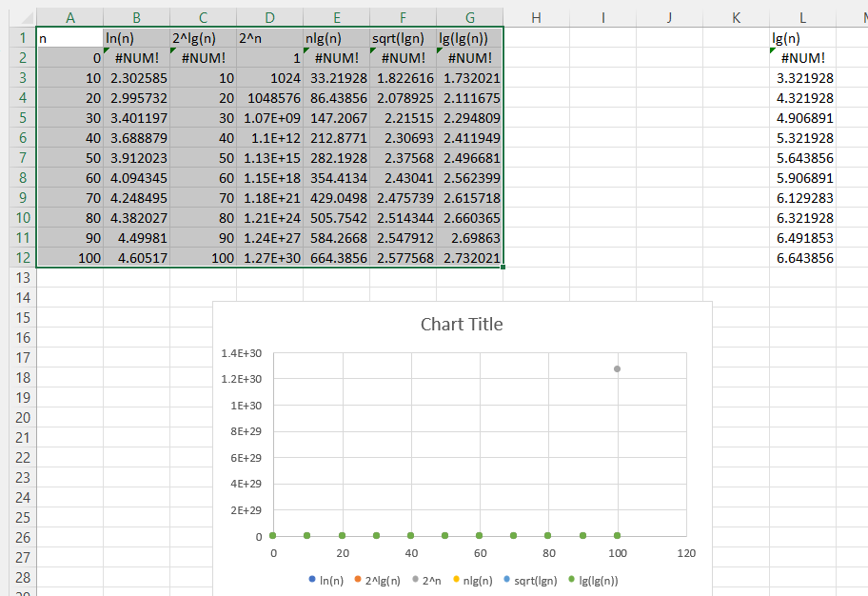  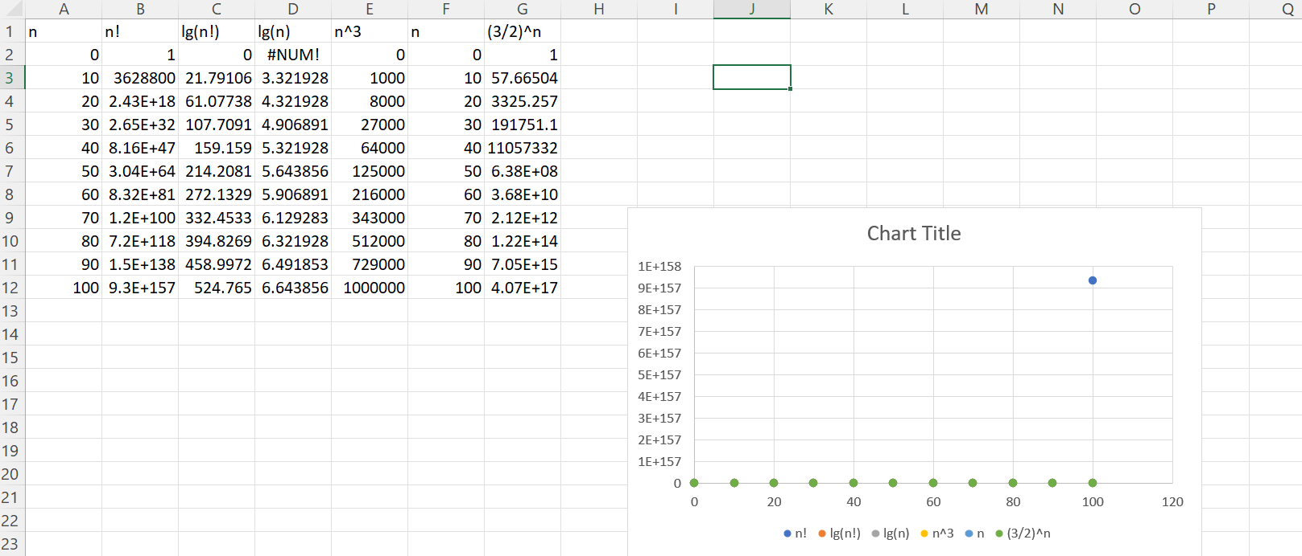  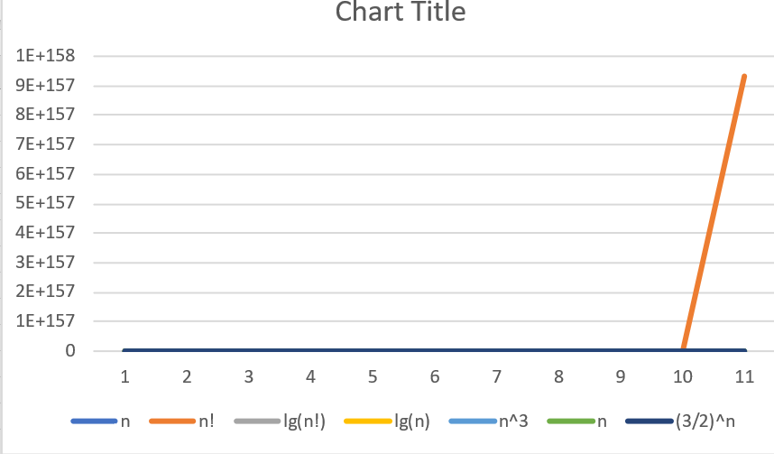  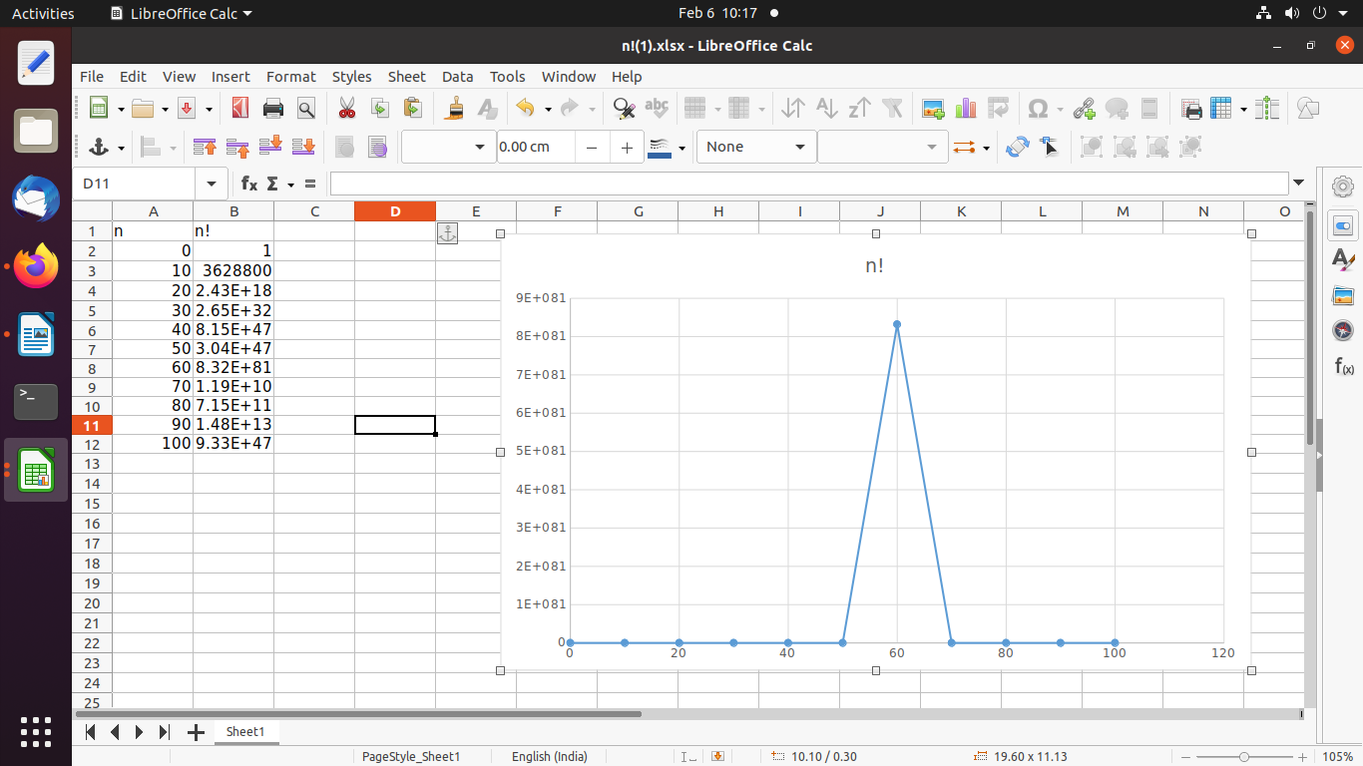
CONCLUSION: | I understand and implemented 10 functions with graph.

